Assignment Day 22 – Web Scraping
By Rizky Febri Ibra Habibie
DS33B

Python code:
Klik Disini

Data CSV:
Klik Disini

Data SQL:
Klik Disini

Query SQL:
create database ubuvilla;

select *
from villa_data;

-- sort price by the most expensive
select *
from villa_data
order by "Price_1" desc;

alter table villa_data
drop column price;

--rework bedroom and capacity
alter table villa_data add column bedroom_num integer;

select
substring("Bedrooms" from '\d+$') AS bedroom_num
from villa_data;

update villa_data
set bedroom_num = cast(substring("Bedrooms" from '\d+$') as integer);

alter table villa_data add column capacity_num integer;

select
substring("Capacity" from '\d+$') AS capacity_num
from villa_data;

update villa_data
set capacity_num = cast(substring("Capacity" from '\d+$') as integer);

-- Villas with more than 2 bedrooms
select *
from villa_data
where cast(bedroom_num as integer) > 2;

--Average price per bedroom count
select bedroom_num,
AVG("Price_1") as avg_price
from villa_data
group by bedroom_num
order by bedroom_num desc;

--Count villas by capacitt
select capacity_num,
COUNT(*) as total_listings
from villa_data
group by capacity_num
order by capacity_num desc;

Hasil Query SQL:
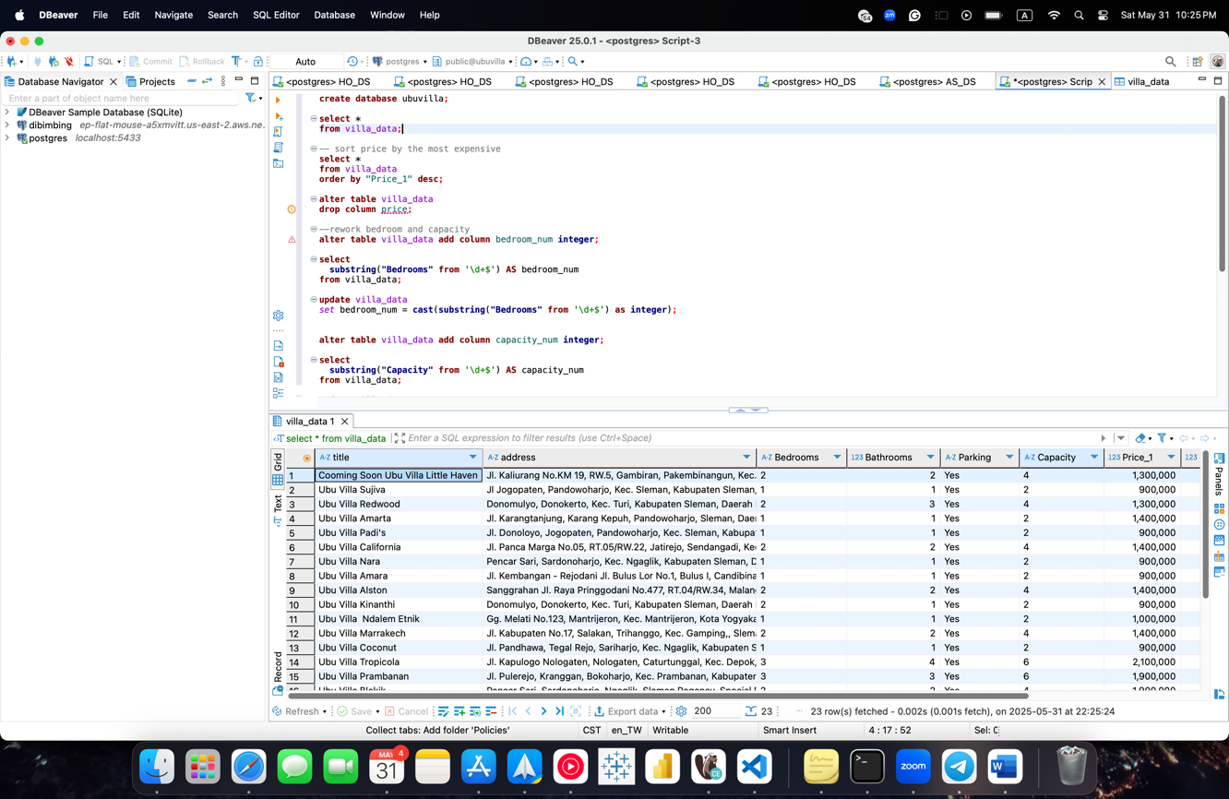
Figure 1. Checking Data Input CSV
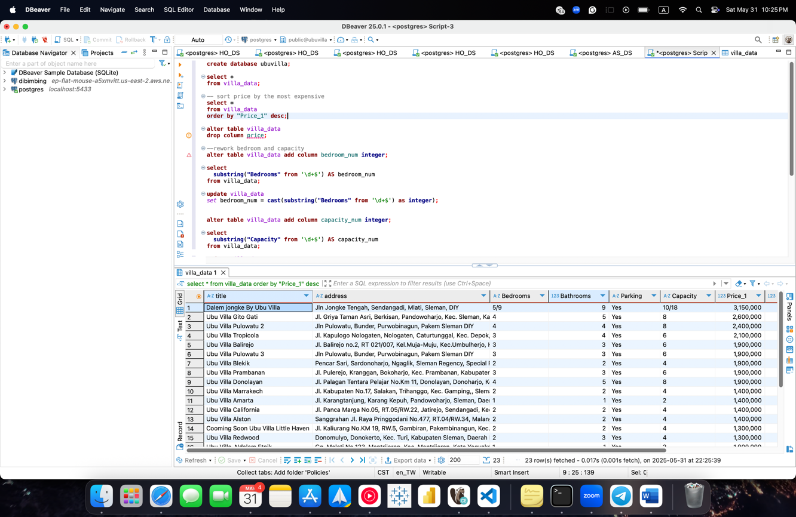
Figure 2. Sort Price by the Most Expensive Property
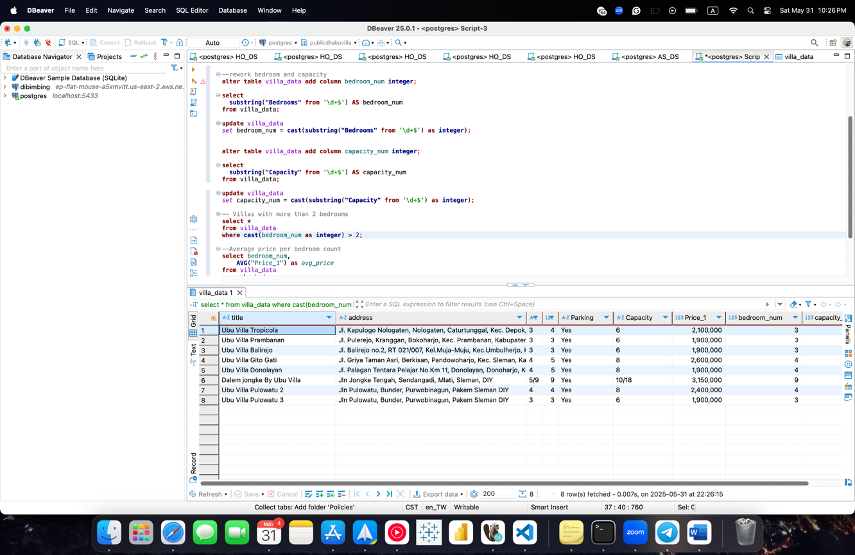
Figure 3. Villas with More than Two Bedrooms
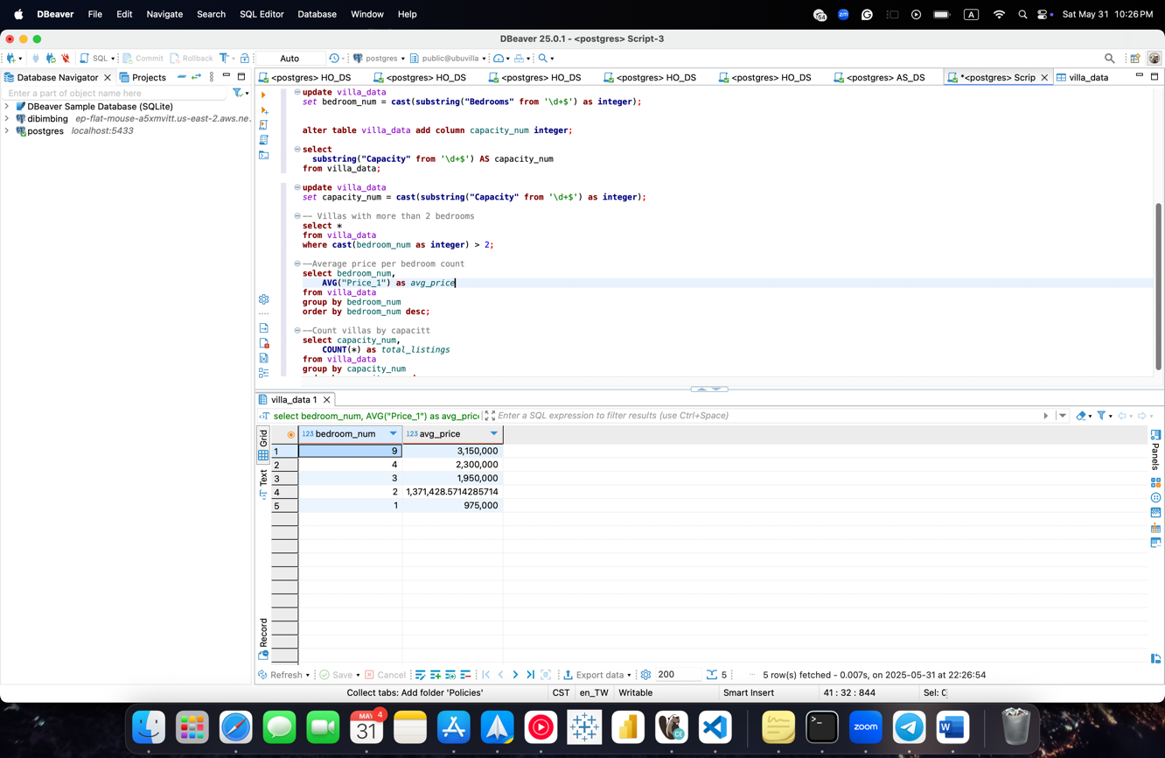
Figure 4. Average Price per Bedroom Count
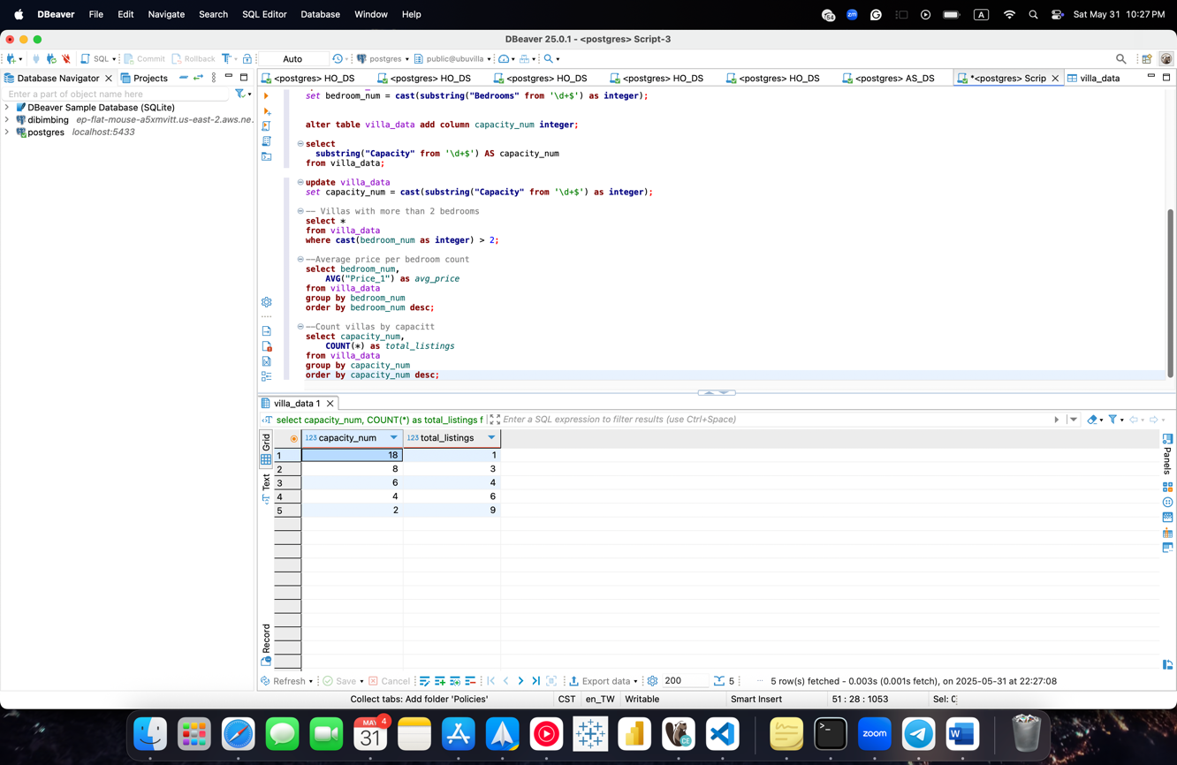
Figure 5. Count Villas by Capacity

